World Pneumonia Day 2018

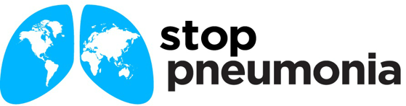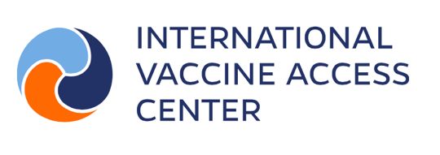

Social media messages

Today we celebrate our 10th #WorldPneumoniaDay – and we have reason to reflect on our progress. This year pneumonia will claim the lives of over half a million fewer children than it did each year when we marked our first World Pneumonia Day. Learn more at www.stoppneumonia.org
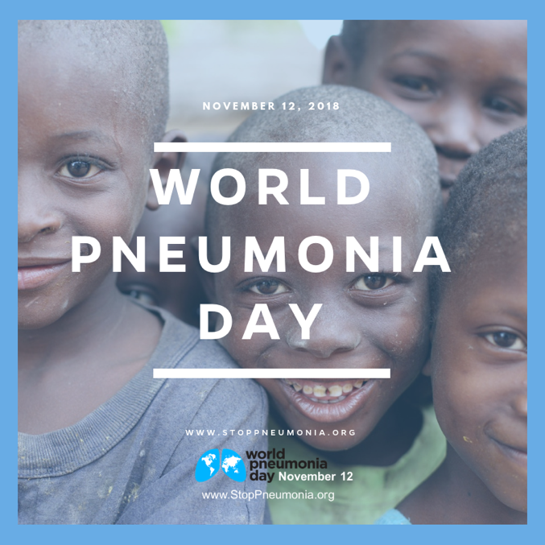

Pneumonia has devastating impacts in low- and middle-income countries, however, with vaccines, nearly a million deaths could be prevented in those populations. Learn more at www.stoppneumonia.org
#StopPneumonia #VaccinesWork
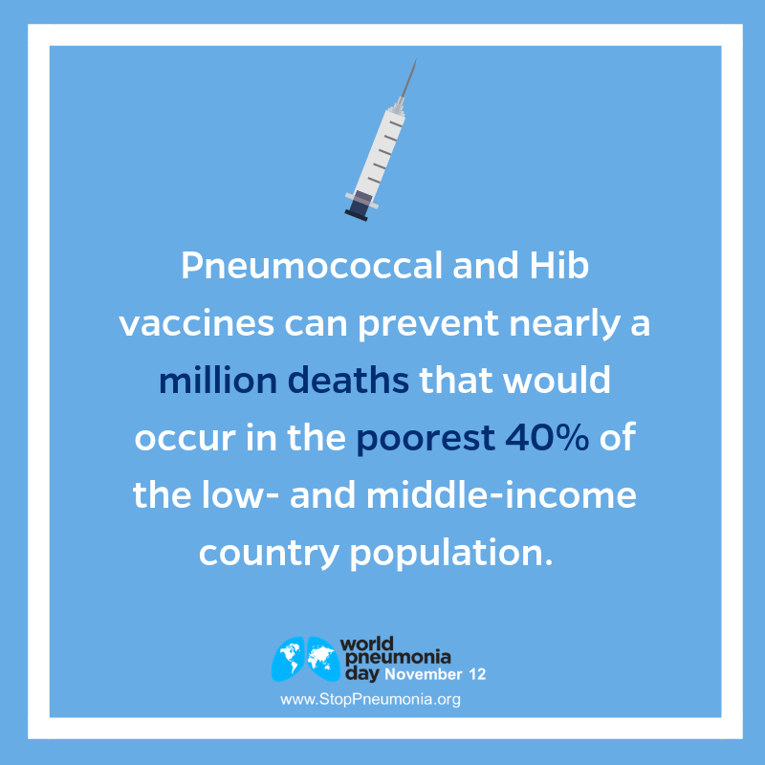

With antibiotic treatment, 70% of childhood deaths from pneumonia could be prevented at a cost of $0.40. Learn more at www.stoppneumonia.org
#StopPneumonia #WorldPneumoniaDay
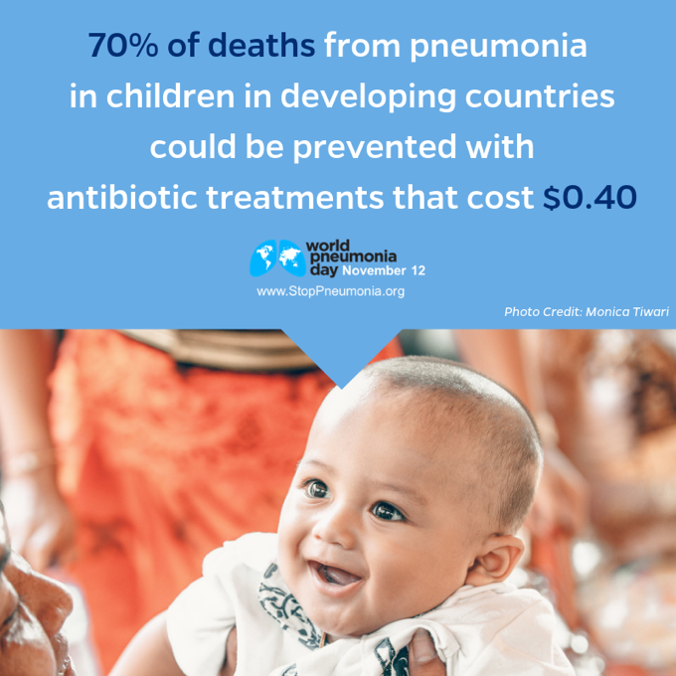
The world has made great progress to cut pneumonia deaths. By investing in global health, we can make dramatic improvements in child health. Learn more at www.stoppneumonia.org
#StopPneumonia #WorldPneumoniaDay
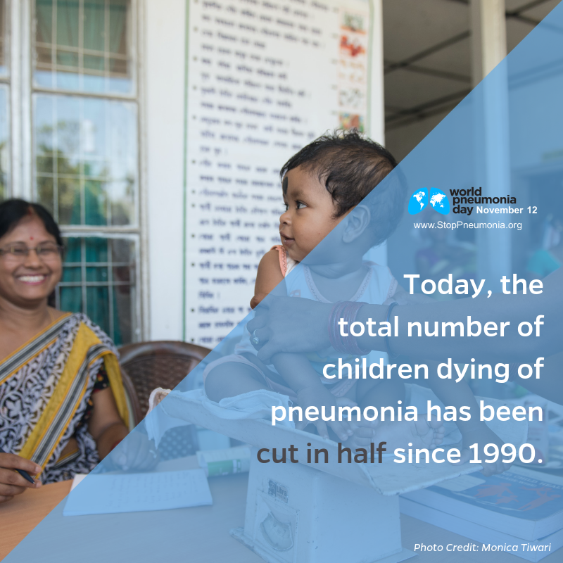

Interventions to prevent and treat pneumonia work! In the past three decades, pneumonia efforts have led to much progress in preventing the deaths of up to 1,000 children each day. Learn more at www.stoppneumonia.org
#StopPneumonia #WorldPneumoniaDay
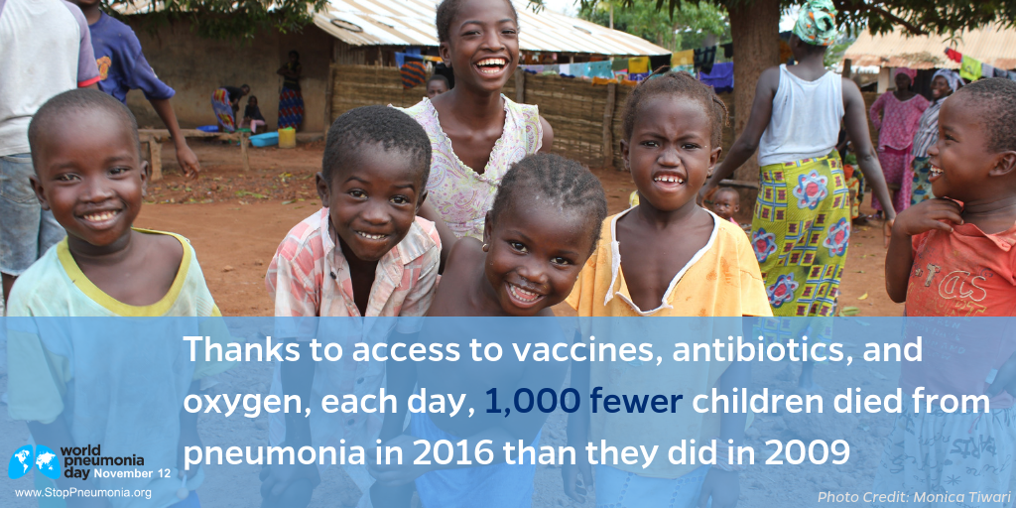

Although tremendous progress has been made, worldwide, pneumonia – a leading killer of children under the age of five – still claims the lives of 2,400 young children every day, 100 children every hour. Learn more at www.stoppneumonia.org
#StopPneumonia #WorldPneumoniaDay
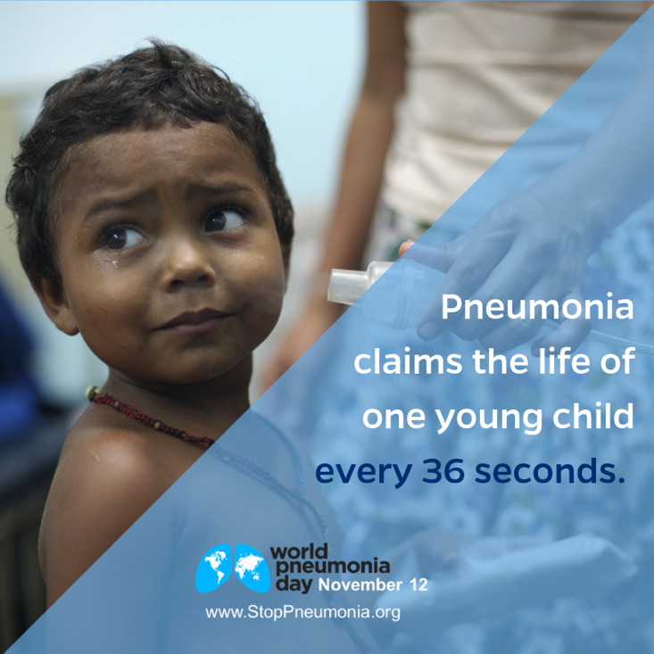

Only when all children have equitable access to pneumonia vaccines and treatments will we be able to make meaningful progress in ending pneumonia. Learn more at www.stoppneumonia.org
#StopPneumonia #VaccinesWork
