Pneumonia and Diarrhea
Progress Report 2018
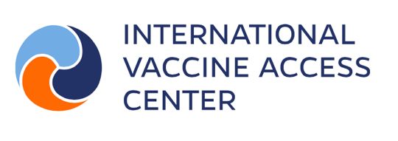

Social media messages

Message 1
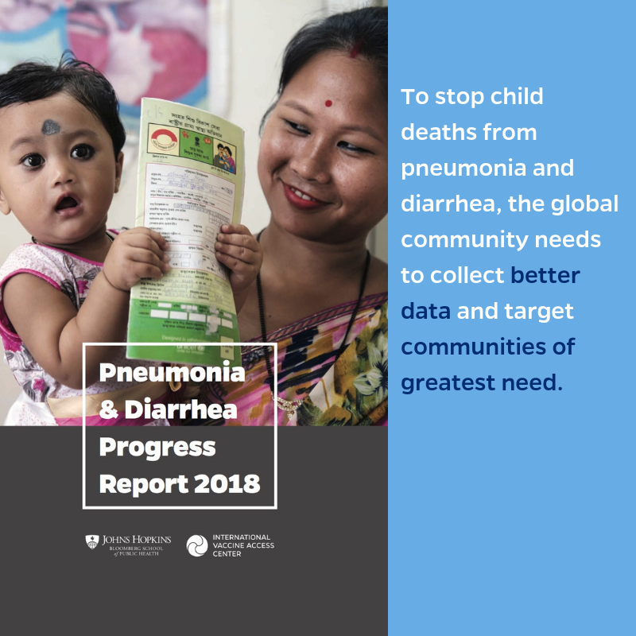
We can’t change what we can’t measure. We need accountability supported by better data to stop child deaths.
bit.ly/pneumonia-progress #PneumoniaDiarrheaReport2018 #StopPneumonia #PneumoniaProgress

Message 2
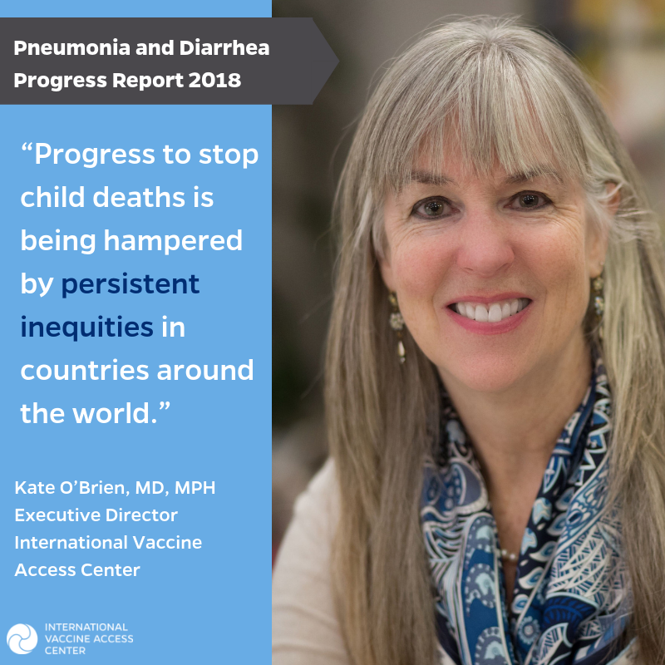
“Addressing inequities will demand greater levels of funding and strong political commitment,” says Kate O’Brien, Executive Director of @IVACTweets.
Learn more about progress toward stopping pneumonia and diarrhea deaths: bit.ly/pneumonia-progress #PneumoniaDiarrheaReport2018
Message 3
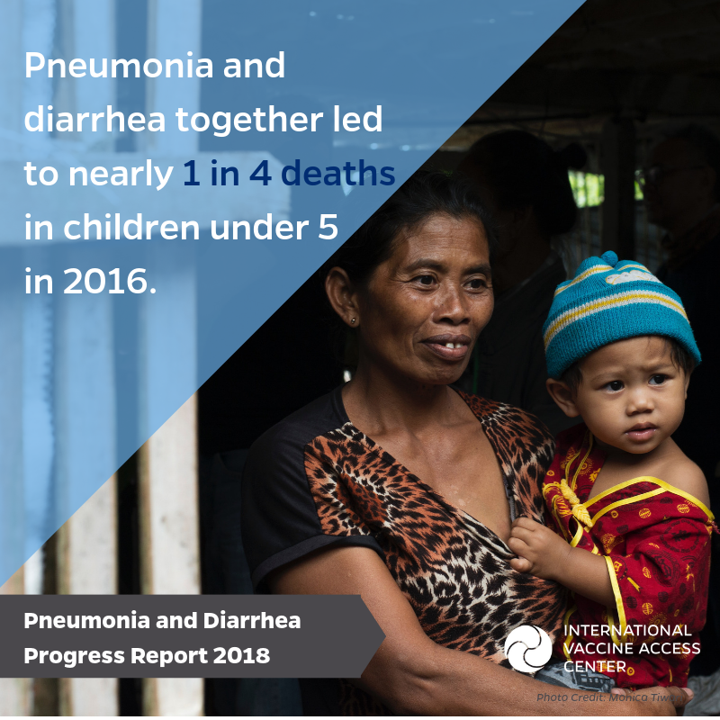
Pneumonia and diarrhea are still leading killers of children under 5. Progress is hampered by inequity in countries with the largest numbers of deaths.
Learn more in the new report bit.ly/pneumonia-progress #PneumoniaDiarrheaReport2018 #StopPneumonia #PneumoniaProgress
Message 4
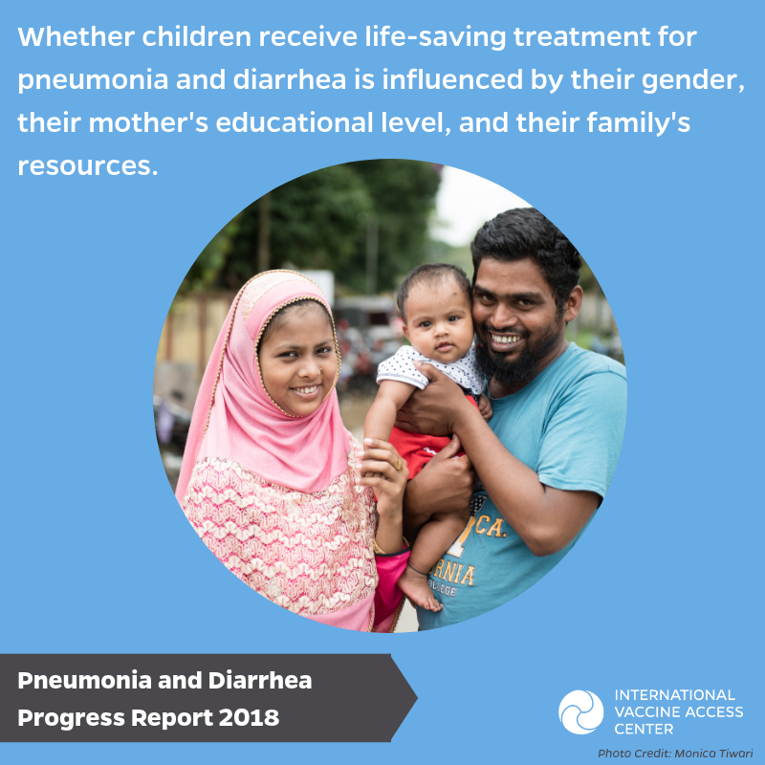
Sad but true: countries’ efforts to treat child pneumonia and diarrhea seriously lag, especially among children who live in remote or impoverished communities.
Learn more in new report bit.ly/pneumonia-progress #PneumoniaDiarrheaReport2018 #StopPneumonia #PneumoniaProgress
Message 5
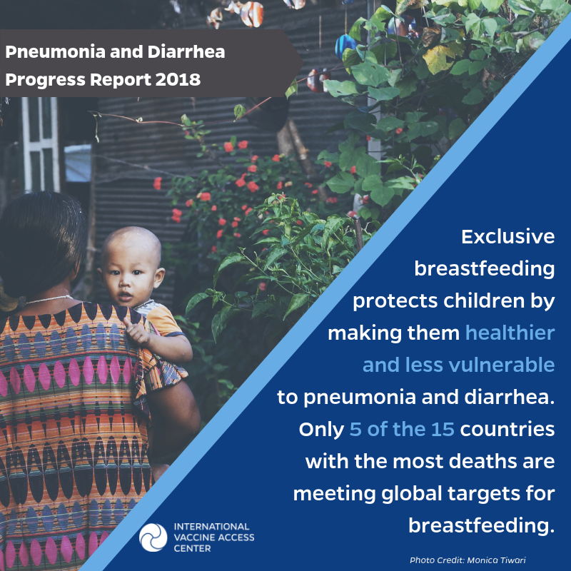
Breastfeeding helps protect children from diseases like pneumonia and diarrhea. Learn other ways to prevent child deaths.
bit.ly/pneumonia-progress #PneumoniaDiarrheaReport2018 #StopPneumonia #PneumoniaProgress
Message 6
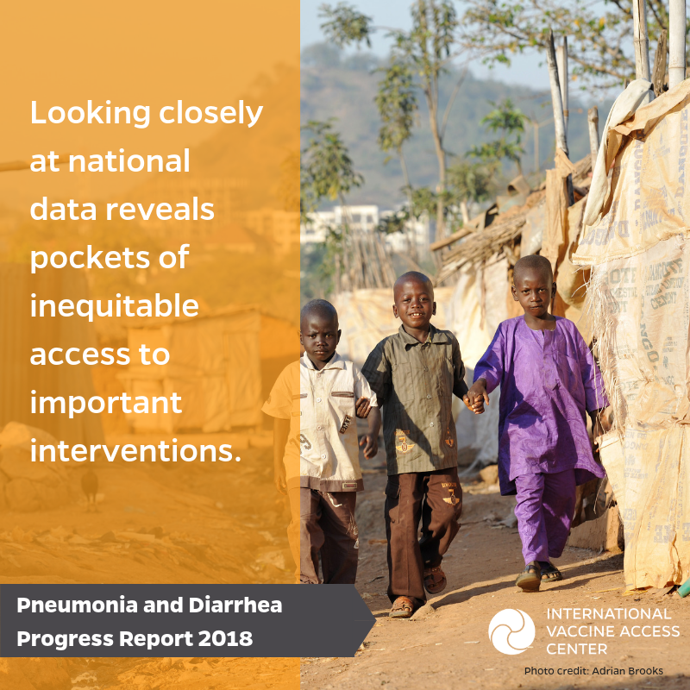
Access to healthcare for pneumonia and diarrhea is unequal but it doesn’t have to be.
Learn about solutions: bit.ly/pneumonia-progress ##PneumoniaDiarrheaReport2018 #StopPneumonia #PneumoniaProgress

