A picture containing nature

Description automatically generatedEvery Breath Counts Social Media Content – WPD 2018A screenshot of a boy


A group of people around each other

Description automatically generatedA crowd of people


A picture containing person, music, phone, talking

Description automatically generatedA group of people looking at the camera

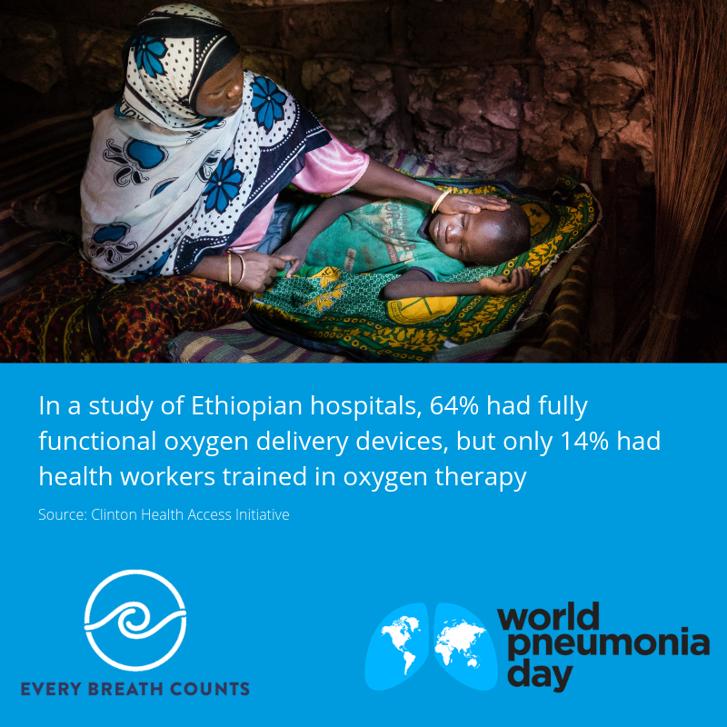A close up of a logo

Description automatically generatedA group of people posing for the camera

Description automatically generatedA picture containing person, indoor

