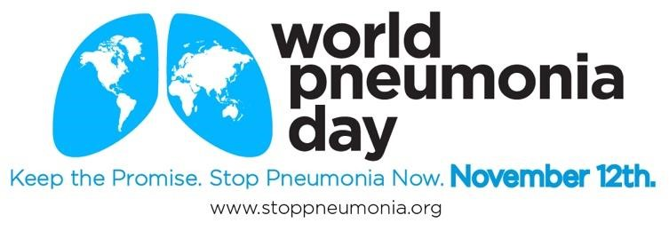

2018 Outreach Toolkit

World Pneumonia Day is November 12. This outreach toolkit is designed to ensure a large and diverse group of child health organizations can participate in promoting this important cause. The kit provides shared messages, tools, and content to help coordinate activities, amplify messages, and disseminate information. We encourage your organization to use, add to, and share this coordination tool with colleague organizations.

This World Pneumonia Day, let’s work together to send a strong message that we must continue to prioritize investments in child health. Every voice is needed. Thank you!

[Please note: This resource will be updated in the weeks leading up to November 12 as organizations share more information about activities.]
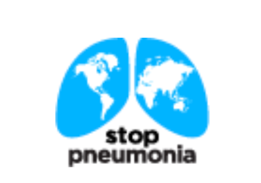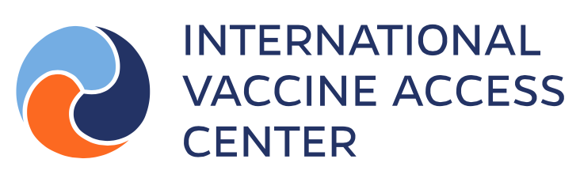

Contact: For more information on World Pneumonia Day or to share advocacy materials you’ve developed, please contact the International Vaccine Access Center (IVAC) at WorldPneumoniaDay@jhu.edu

This year’s theme: Stop Pneumonia: 10 Years of Progress and the path forward.

Pneumonia is a leading cause of death for children around the world, taking more young lives than malaria, TB, HIV, Zika and Ebola combined. We can save thousands of young lives by investing in pneumonia prevention and treatment. An investment in the fight against pneumonia pays great dividends. The interventions for tackling pneumonia are integral to achieve overall child health, and are needed to reach Sustainable Development Goal (SDG) 3 by 2030, to reduce child mortality.

Key Messages

World Pneumonia Day, marked each year on November 12, presents an opportunity to focus on child health challenges around the world. The goal is to raise awareness about pneumonia progress, current obstacles and inequities, and promote prevention and treatment. We – as a global community – need to generate action to fight the illness by bringing together donors, policymakers, health care professionals, and the public. Despite dramatic improvements in child health in the last 20 years, too many young lives are lost to pneumonia and other common childhood illnesses. We must advocate for investments to improve child health.

Pneumonia is a leading killer of young children
      - Pneumonia continues to be the #1 infectious killer of children under the age of five worldwide – more than HIV, TB, Zika, Ebola, and malaria combined.
      - In 2016, nearly 900,000 children worldwide died from pneumonia before their 5th birthday.
      - Today, we celebrate our 10th World Pneumonia Day – and we have reason to reflect on our progress. This year, pneumonia will claim the lives of over half a million fewer children than it did each year when we first recognized World Pneumonia Day.
      - Worldwide, pneumonia, a leading killer of children under the age of five, claims the lives of 2,400 young children every day – 100 children every hour. Pneumonia claims one young child every 36 seconds.
      - People of any age, in every country, are at risk of contracting pneumonia, but a disproportionate number of all childhood deaths from pneumonia occur in impoverished countries, due to conflict, poverty, and weak health systems.
      - For children who acquire pneumonia in developing countries, 70% of deaths could be prevented with appropriate antibiotic treatment that costs $0.40 for a course of treatment.

      - Equity: Girls in South Asia are 43% more likely to die from pneumonia than are boys.
      - Equity: To make progress in reducing the number of pneumonia-related deaths, significant efforts need to be made to equitably reach, immunize, and provide health services for those hard-to-reach children. This is the only way we can reach our goals of ending preventable child deaths.
      - Progress: Interventions to prevent and treat pneumonia work! In the last three decades, millions of children’s lives have been saved thanks to access to vaccines, antibiotics, and oxygen. Scaling up pneumonia efforts in the past decade have led to progress – each day, 1,000 fewer children died from pneumonia in 2016 than they did in 2009.

Investing in child health pays off
- The number of children dying has been cut in half since 1990, but we can’t stop here. By investing in global health, we can make dramatic improvements in child health.

- Affordable and effective interventions like vaccines, oxygen, antibiotics, hand-washing, and breastfeeding have proven track records and immediate impacts.
- Pneumococcal and Hib vaccines can prevent nearly a million deaths that would occur in the poorest 40% of the low- and middle-income country population.
- In addition to causing substantial child mortality, pneumonia also pushes many families into poverty – vaccination help can protect against both.
- Insufficient breastfeeding can leave children undernourished and at an increased risk of pneumonia. Breastfeeding can prevent about one third of all respiratory infections and over half of hospitalizations from respiratory infections. Exclusive breastfeeding can help to strengthen the immune systems of infants and children, to enable them to better defend against infections such as pneumonia.
- Equity: Life-saving pneumonia vaccinations and treatments exist. However, inequitable distribution leaves some groups disproportionately vulnerable to pneumonia. We must invest in the development and scale-up of effective pneumonia interventions that prioritize the at-risk and underserved populations.

Pneumonia and diarrhea are tackled together
• Burden: Pneumonia and diarrhea are common childhood illnesses from which children everywhere suffer. However, children in low-resource settings too often lack access to vaccines, medicine, and medical care that lessen the severity or prevent the illnesses. As a result, these common, highly preventable and treatable illnesses take over a million young lives each year.
- Despite global efforts, the leading killers remain the same – pneumonia and diarrhea claimed more than 1.3 million child lives each year, roughly one in every 4 deaths of children under 5 years of age. Many are preventable.
- Treating illness: Pneumonia disproportionally affects the poorest families – families who are least likely to be able to afford treatment. Families are forced to borrow money and lose assets to pay for treatment and hospitalizations that could have been almost entirely prevented. We must invest to prevent the cycle of illness and poverty now.
- Integration: Pneumonia and diarrhea are leading killers of children and can be tackled together with interventions such as breastfeeding, water, sanitation, and hygiene (WASH) improvements, vaccines, and access to medical care to diagnose and treat illness. Each intervention alone is not enough. It is critical to promote a set of health practices to prevent and treat pneumonia and diarrhea.
Pneumonia and the global goals
- As world leaders work to meet the UN Sustainable Development Goals (SDGs), this is the time to take action to make investments that will improve child health. Investing in pneumonia interventions can directly help us achieve multiple SDGs: SDG 3 – Good health and well-being, SDG 1 – No poverty, and SDG 10 – No inequalities.
Call to action
World Pneumonia Day is an opportunity to act on behalf of all the world’s children. Now is the time to invest in child health and save young lives. We must hold governments accountable and provide families everywhere with the tools they need to prevent and treat pneumonia and other illnesses. Everyone has a role to play.

- Donors must continue and scale up investments to 1) support the identification of the root causes of inequity, and 2) enable the development and implementation of targeted solutions to address those inequities that exist. The global community must create a comprehensive, integrated strategy that addresses the necessary system-level changes to support these highest burden countries in efforts to achieve GAPPD targets for all children

- Governments can prioritize child health and invest in the fight against pneumonia and diarrhea. They can increase funding to: 1) scale-up existing programs to prevent and treat pneumonia, 2) develop new tools to fight pneumonia, 3) evaluate programs and monitor progress, 4) increase the frequency of collection and the quality of data on progress to aid decision making, and 5) develop programs targeted to areas of inequitable distribution of pneumonia vaccination and treatments.
- Governments must address inequalities in the distribution of pneumonia prevention and treatments to at-risk children, irrespective of gender and among those living in poverty and in remote locations.
- Citizens can hold governments accountable and demand they prioritize child health so all families have the tools they need to help their children fight common illnesses.
- Health workers can continue to employ evidence-based approaches to prevent, diagnose, and treat pneumonia. They can also educate policymakers and the public about the prevalence and consequence of the illness.
- Researchers need to invest in collecting timely data in all regions to better understand the locations and causes of inequities within each country. Researcher must continue to explore innovations, particularly those that address inequities of access to pneumonia vaccines, diagnostics and medicine. Providing families with the tools they need to keep their children healthy will increase the well-being of families, communities, and countries.

