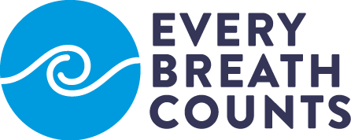

a public-private partnership
to support national governments
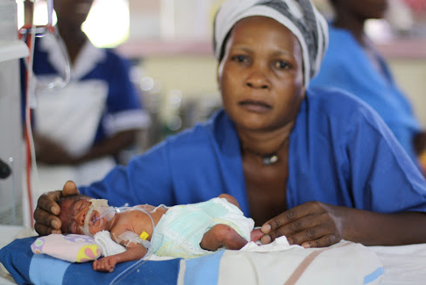
to end child pneumonia deaths by 2030
Photo: ADARA Development

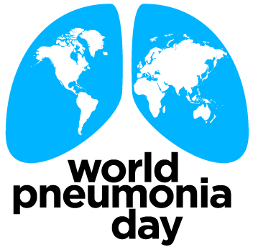
2018

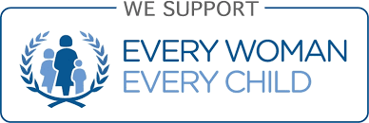
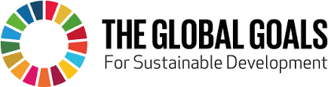

An unprecedented number of organizations representing governments, business, United Nations and development agencies has joined forces in the Every Breath Counts Coalition; a first-of-its-kind partnership to support national governments to end preventable child pneumonia deaths by 2030, with a special focus on the countries with the largest populations of children under five at greatest risk of death.

Pneumonia kills almost one million children under five each year, including an estimated 180,000 newborns and 770,000 children. Between 2000 and 2015, child pneumonia deaths fell by 47%, compared to 85% for measles, 61% for AIDS, 58% for malaria and 57% for diarrhea. If this slow rate of change continues, more than 700,000 children under five will still be dying from pneumonia in 2030, and the goal of ending preventable child deaths will not be achieved in many countries.

Children in countries like Chad, Nigeria, Angola, Niger, Somalia, Mali, the Democratic Republic of Congo, Afghanistan, Pakistan and Ethiopia are especially vulnerable to death from pneumonia. The combination of high child malnutrition and household air pollution, with low vaccine coverage, breastfeeding rates, female literacy and poor access to health services exposes these children to higher risks. Focused national and international efforts to identify and close gaps in pneumonia prevention, diagnosis and treatment in these countries could prevent more than 250,000 child deaths from pneumonia each year.

To help governments in these countries end preventable child pneumonia deaths by 2030, the Every Breath Counts Coalition will provide support to close critical gaps in pneumonia prevention, diagnosis and treatment. In some countries expanding pneumococcal vaccine coverage will be the top priority, while in others improving access to proper diagnosis and treatment services with better tools like pulse oximetry and increased access to child-friendly antibiotics and oxygen will be key. Working more directly with mothers and families to improve breastfeeding rates, child nutrition and female literacy and reduce household air pollution will boost progress across all countries.

Specific activities the Every Breath Counts Coalition will prioritize in the focus countries in partnership with governments include, but will not be limited to:

- developing national child pneumonia control strategies based on local cause-of-death data and local gaps in coverage of the highest-impact interventions;

- increasing the proportion of both domestic health resources and international development assistance allocated to child health and pneumonia-related interventions (e.g. vaccination, child nutrition, air pollution, diagnosis, and access to child-friendly antibiotic and oxygen therapies;

- support for country efforts to prioritize child pneumonia in their investment cases for funding from the Global Financing Facility in support of Every Woman, Every Child;

- accelerating introduction of the pneumococcal vaccine in countries with no coverage and increased efforts to lift coverage to above 80% in low coverage countries;

- advancing Universal Health Coverage (UHC) that prioritizes providing frontline health workers and health facilities that serve newborns and children with improved pneumonia diagnostic and treatment tools, especially improved pneumonia diagnostic tools, pulse oximetry and oxygen therapies;

- expanding training for healthcare workers to use new pneumonia-related diagnostic and treatment technologies, including specific training to reduce newborn pneumonia mortality;

- including critical pneumonia diagnostic and treatment tools on World Health Organisation (WHO) guidance to national governments, including Essential Medicines and related lists;

- increasing investments in innovations that improve the cost-effectiveness of pneumonia prevention, diagnosis and treatment, with a special focus on supporting local entrepreneurs with sustainable business models;

- introducing global and national advocacy campaigns to increase the investments needed to end preventable child pneumonia deaths by 2030, to raise awareness about child pneumonia deaths among all stakeholders, including the general public, and to encourage social and behavioral change by caregivers and healthcare workers;

- providing more technical assistance from international development agencies to assist Ministries of Health to accelerate reductions in child pneumonia deaths;

- including a more robust set of pneumonia prevention, diagnosis and treatment indicators in official health surveys (e.g. MICs, DHS) and health impact tools, especially the Lives Saved Tool (LiST) model;

- coordinating efforts by humanitarian agencies to reduce child pneumonia mortality and to test new approaches to pneumonia prevention, diagnosis and treatment in specific conflict settings; and

- increasing research to identify the predictors of development of severe pneumonia and the children who require urgent referral or hospitalization.

The Coalition will regularly report progress during the UN General Assembly and at the Spring World Bank meetings.

The Every Breath Counts Coalition is in support of the Sustainable Development Goals, especially SDG 3.2, the Global Strategy for Women’s, Children’s and Adolescents' Health and the UN Secretary-General’s Every Woman, Every Child (EWEC) movement.

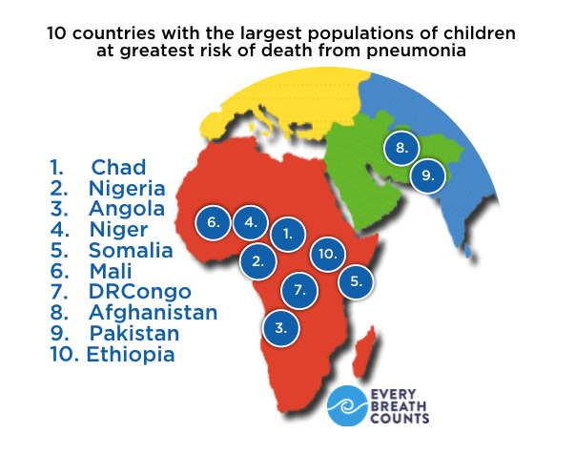

Why do we need an Every Breath Counts Coalition?

(1) current approaches to fighting child pneumonia are not reducing deaths fast enough

- Childhood pneumonia kills more children under five than any other infection.

- In 2015, UNICEF estimated pneumonia killed 950,000 children - 180,000 newborns and 770,000 children aged 1 to 60 months).

- In contrast, in 2015, diarrhea caused an estimated 535,000 deaths, malaria 300,000, HIV/AIDS 59,000 and measles 59,000.

(2) Childhood pneumonia deaths are declining more slowly than malaria, HIV/AIDS, measles and diarrhea deaths
- Between 2000 and 2015, UNICEF estimated that child pneumonia deaths fell by 47% compared to 85% for measles, 61% for AIDS, 58% for malaria and 57% for diarrhea.
- Within many countries, most of them in sub-Saharan Africa, pneumonia deaths have not fallen at all or have actually increased.
- Between 1990 and 2013, the Institute for Health Metrics and Evaluation (IHME) reported that pneumonia deaths fell marginally in Mali, Burkina Faso, Somalia, Angola, Tanzania, Malawi, Cote d’Ivoire, Uganda, Kenya, and Nigeria, and actually rose in Afghanistan, Cameroon, Democratic Republic of Congo and Chad.
(3) Many high child pneumonia mortality countries are managing to reduce child deaths from HIV/AIDS, diarrhea, measles and malaria
- Between 1990 and 2013, the IHME reported that most countries failed to reduce their child pneumonia deaths significantly, even while they were achieving large reductions in reducing child deaths from diarrhea, measles, malaria and HIV/AIDS, especially Tanzania, Ethiopia and Uganda.
- In a subset of countries, child pneumonia deaths rose while deaths from malaria fell, including in the Democratic Republic of Congo and Kenya.
(4) Global health investment specifically for pneumonia remains low and stands in stark contrast to the proportion of deaths pneumonia causes
- National resources for health have stagnated over the last fifteen years, with little evidence of increased prioritization of health within national budgets and the continued burden of out-of-pocket payments on the poor.
- The IHME found that just 2% of international development assistance for health was allocated specifically to pneumonia in 2011, when it was responsible for 14% of child deaths.
- Put another way, for every $1 in global health assistance in 2011, 2 cents was invested in fighting pneumonia, the leading killer of children.
- The majority of the 2% of development assistance for health ($US80 billion) spent fighting pneumonia was allocated to vaccines, specifically the introduction of the Hib and pneumococcal vaccines which target the leading causes of severe pneumonia. Other aid does support primary health care and Universal Health Coverage as well as services such as integrated Community Case Management.

(5) At current rates of progress and levels of investment, a subset of countries with high child mortality cannot achieve Sustainable Development Goal 3.2 by 2030
- UNICEF estimated that four countries would need to accelerate their rate of progress more than five times to achieve SDG 3.2 (Angola, Somalia, Chad and Central African Republic), while a further six countries would need to move three to five times as fast (Lesotho, Benin, Mauritania, Afghanistan, Pakistan and Comoros).
- For a subset of “off-track” countries - those with high child mortality rates, slow progress and large pneumonia burdens - pneumonia will likely be the largest barrier to achieving SDG 3 (Angola, Chad, Somalia, Central African Republic, Nigeria, Benin, Democratic Republic of Congo, Niger, Lesotho, Cote d’Ivoire).
Why focus on specific countries?
(1) Efforts to reduce child pneumonia deaths can have their greatest impact on child survival and SDG 3.2 when they are targeted to the countries with the largest numbers of children at highest risk of death
- These are likely to be the countries with the largest numbers of child pneumonia deaths, the heaviest pneumonia burdens (around 20% all child deaths), the highest child mortality rates, the slowest progress in reducing those rates, the lowest pneumococcal vaccine coverage, breastfeeding and female literacy rates, the highest rates of child malnutrition (especially wasting), the heaviest dependence on solid cooking fuels, and high rates of urbanization (as crowding and air pollution are highly correlated with urbanization).
- The countries that score the highest across this suite of indicators include, in order of priority, Chad, Nigeria, Angola, Niger, Somalia, Mali, Democratic Republic of Congo, Afghanistan, Pakistan and Ethiopia.
- The first five countries are in “urgent” need of greater levels of attention and investment to fighting child pneumonia, while the second five are a “priority” for action.
(2) Maintaining the status quo in these ten countries would result in minimal number of child deaths prevented in 2030
- UNICEF estimated that 374,000 children died from pneumonia in these ten countries in 2015. At current rates of progress an estimated 353,000 children would die from pneumonia in 2030 across these ten countries. The status quo option would see little change in terms of number of deaths.
- At this rate of progress, all of the countries would miss the target levels of child pneumonia deaths required to achieve SDG 3.2, most by more than 60%. For example, at current rates of progress Nigeria will still be losing 110,000 children to pneumonia in 2030, compared to their SDG target of 39,000 child pneumonia deaths. Focus countries with the widest gaps include Angola, Chad, Nigeria, Somalia and Mali.
- Slow progress on reducing child pneumonia deaths will likely prevent the achievement of SDG 3.2 in all of these countries.
(3) Aggressively filling gaps in pneumonia control (prevention, diagnosis and treatment) in Chad, Nigeria, Angola, Niger and Somalia (the five “urgent” action countries) could prevent an additional 160,000 child deaths from pneumonia in 2030
- Specific “pneumonia control” plans would be required in each of the five countries with gaps in coverage identified and filled. For example, Chad and Somalia’s highest priorities might be introduction of the pneumococcal vaccine, while Nigeria’s and Afghanistan’s goals could be to rapidly increase coverage of the pneumococcal vaccine among the most vulnerable populations of children.
- Countries with higher pneumococcal vaccine coverage (e.g. Mali, Democratic Republic of Congo, Pakistan and Ethiopia) could invest more in rapid diagnosis of pneumonia and antibiotic treatment at the community level while increasing access to pulse oximetry and oxygen in facilities.
- Countries with low female literacy and high rates of child wasting and cooking with solid fuels (e.g. Niger) could invest more in family nutrition and mother education campaigns while subsidizing clean cooking fuels.
- Countries that score poorly across all indicators (e.g. Angola) should target action on all fronts to fight pneumonia.
- In all of these countries national plans/strategies to identify and close pneumonia gaps and secure domestic sources of financing before external support is offered are critical.

(4) Aggressively filling gaps in pneumonia control (prevention, diagnosis and treatment) in all ten focus countries could prevent an additional 250,000 child deaths from pneumonia in 2030
- Specific “pneumonia control” plans would be required in each of the additional five countries with gaps in coverage identified and filled. For example, while pneumococcal vaccine coverage is rising in the additional five countries (Mali, Democratic Republic of Congo, Afghanistan, Pakistan and Ethiopia), gaps in diagnosis and treatment are wide.
- As female literacy is very low in the additional five countries, it should be a special focus of pneumonia control, including efforts to educate mothers to recognize the signs of pneumonia and to seek appropriate care quickly.
- Investments in reducing reliance on solid cooking fuels will also be important in Mali, Democratic Republic of Congo and Ethiopia, while breastfeeding support and infant nutrition will be critical in all five countries as all suffer from low breastfeeding rates and 8%+ child wasting rates.
(5) It is only possible to achieve the SDG-required child pneumonia mortality reductions in these countries if governments, businesses and civil society join forces to invest in closing the gaps
- A public-private partnership with an ambitious, measurable goal - to end preventable child pneumonia deaths in the focus countries by 2030 - can crowd in resources to the most vulnerable populations of at risk children.

- Given the importance of the Global Financing Facility (GFF) as a leading source of external financial assistance for women’s, children’s and adolescents’ health in eligible countries, there should be efforts to engage and offer support to the focus countries that are GFF-eligible (e.g. Chad, Angola, Niger, Somalia, Mali, Afghanistan and Pakistan).

- The Every Breath Counts Coalition will amplify the efforts of the various child pneumonia initiatives already underway including the United4Oxygen Alliance, HO2PE, the Pneumonia Innovations Network, Stop Pneumonia/World Pneumonia Day, the ARIDA Project, the Save the Children and GSK partnership, Saving Lives at Birth and Grand Challenges Canada, as well as work underway by Results for Development, the Global Alliance for Clean Cookstoves and the Clinton Health Access Initiative.

- Building bridges with the various child pneumonia-related research underway, especially the multi-country enhanced community management and clean cooking trials will also be a priority.

What will Every Breath Counts Coalition partners be doing?

(in alphabetical order)
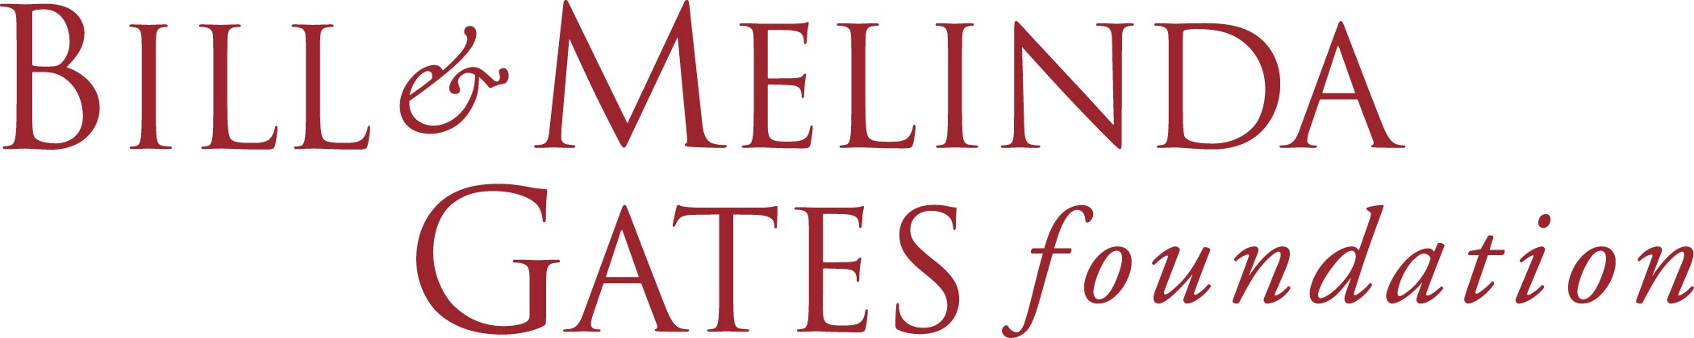

The Bill & Melinda Gates Foundation (BMGF) is a private foundation and a major funder of global health initiatives with a special focus on child survival. The Foundation is a leader in childhood vaccine investment, policy and programs and more recently has taken a strong position in childhood pneumonia diagnosis and treatment. The Foundation is also active in supporting research on household air pollution and infant nutrition, where it also has extensive program investments. The Foundation is one of the only funders with a portfolio of investments that touch on all aspects of the childhood pneumonia challenge.

Guided by the belief that every life has equal value, the Bill & Melinda Gates Foundation works to help all people lead healthy, productive lives. In support of the Sustainable Development Goals, the Bill & Melinda Gates Foundation’s pneumonia strategy focuses on the most prevalent causes of childhood pneumonia. Our top priority is to promote full-scale delivery of currently available pneumococcal and meningococcal vaccines, and to support the development of new vaccines to improve coverage, efficacy, safety, and cost effectiveness. Because vaccines cannot prevent all cases of pneumonia and because the incidence of this disease remains high, BMGF also works to improve access to diagnostics and treatment options which include oxygen related systems improvements in the public and private health sectors. BMGF is developing a platform for maternal immunization to protect mothers and their newborns from pathogens that bear a disproportionate mortality burden in the neonatal period. The BMGF will continue to work though partners like GAVI, the Vaccine Alliance, to increase immunization coverage in the world’s poorest countries, and the Global Financing Facility, to help countries reach those who do not yet have access to quality services and accelerate progress on reproductive, maternal, newborn, child, and adolescent health and nutrition.
.

The Clinton Health Access Initiative (CHAI) is a non-profit organization working in low and middle income countries on access to essential medicines and technologies, among other things. CHAI currently works in five countries on pneumonia - Ethiopia, Nigeria (three states), Kenya, Uganda, and India (one state) - to increase access to amoxicillin, pulse oximetry and oxygen.

The Clinton Health Access Initiative (CHAI) will work with the Governments of Ethiopia and Nigeria to increase access in both the public and private health sectors to treatment for childhood pneumonia—including oxygen for hypoxemia, and amoxicillin dispersible tablets for non-severe cases, and pulse oximetry for diagnosis. CHAI is supporting the governments to develop and implement first-ever national roadmaps for scaling up oxygen access. With support from the Bill & Melinda Gates Foundation, CHAI is supporting governments to improve the policy environment and availability of these commodities in Ethiopia (Tigray, Oromia, Amhara, and SNNPR) and Nigeria (Kano, Kaduna, and Niger states). Results and lessons from the program will benefit CHAI’s efforts in three additional countries working to reduce pneumonia deaths—including Uganda, Kenya, and India (state of Madhya Pradesh).

Concern Worldwide, Ireland’s largest humanitarian and development organization, works to improve education, health and nutrition, and access to livelihoods, water and sanitation in 26 of the world’s poorest countries, including all of the ten Every Breath Counts focus countries.

Concern will ensure that its country teams understand the need for more coordinated efforts to reduce child pneumonia deaths and will prioritize programs to strengthen prevention (vaccination, WASH solutions and infant/young child nutrition, including breastfeeding), diagnosis and prompt treatment as close to home as possible. Concern will intensify its efforts in the focus countries with large displaced or refugee populations to ensure that the most vulnerable children have good nutrition and safe and healthy shelter to protect them from pneumonia and other infectious diseases.

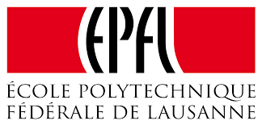
The École Polytechnique Fédérale de Lausanne (EPFL) hosts The EssentialTech program, which aims to develop essential technologies that have the potential to reduce poverty. Its approach combines technology development with the elaboration of innovative business models for a sustainable and large-scale impact. Essential Tech identifies needs for essential technologies in close collaboration with local partners, develops technology innovations adapted to local contexts, designs sustainable solutions through viable business models and aims to achieve large-scale impact via entrepreneurship.
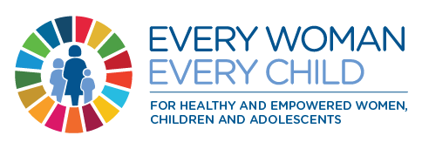
EPFL will, through the EssentialTech program hosted at the Cooperation and Development Centre, develop and deploy an innovative cost-effective, robust oxygen concentrator solution for use in the ten Every Breath Counts focus countries. This solution will include both technology and a sustainable business model, involving all aspects of the value chain such as manufacturing, logistics, commissioning, training, usability, maintenance, repair, obsolescence, and recycling. An alliance of public and private partners, based both in industrialized and in low-income countries, has been assembled to tackle this challenge.
The Every Woman Every Child (EWEC) Innovation Marketplace is an alliance including the Bill & Melinda Gates Foundation (BMGF), Grand Challenges Canada (GCC), the United States Agency for International Development (USAID), the Norwegian Agency for Development Cooperation (NORAD) and UBS Optimus Foundation. The Marketplace’s mandate is to facilitate the transition to scale of promising investments and by 2030 to see at least 10 widely available and having significant positive impact on women, children, and adolescents in low and middle-income countries.

The EWEC innovation Marketplace will support innovations that target the leading killers of children under five including pneumonia. Through it activities of curation and brokering, the Marketplace will identify and help to catalyze investments in child-friendly medications and devices which will improve diagnosis and treatment of pneumonia in children in low and middle-income countries.

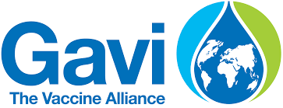
Gavi is a global alliance bringing together public and private sectors with the shared goal of creating equal access to new and underused vaccines for children living in the world’s poorest countries. Created in 2000, Gavi has supported many lower income countries to introduce vaccines that target the leading killers of children, including the Pneumococcal Conjugate Vaccine (PCV3) which targets the leading cause of severe pneumonia among children.

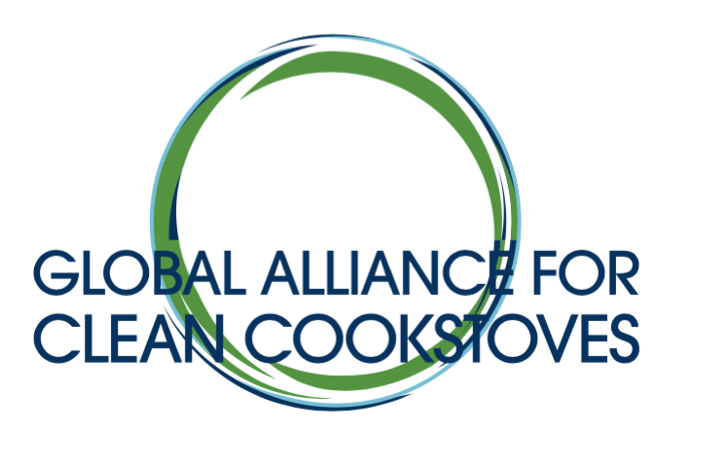
Gavi will engage governments in the focus countries with no PCV3 coverage to explore accelerated introduction of the vaccine and increase coverage of the vaccine in those focus countries with very low coverage. When introducing or expanding PCV3 coverage in the focus countries, Gavi will work with governments and other partners to ensure that other aspects of pneumonia prevention, diagnosis and treatment are integrated with vaccine promotion, training and delivery to increase impact on child lives saved and strengthen health systems.

The Global Alliance for Clean Cookstoves (GACC) is a non-profit public-private partnership hosted by the UN Foundation to enable a global market for clean and efficient household cooking solutions. The Alliance’s 100 by 2020 goal calls for 100 million households to adopt clean and efficient cookstoves and fuels by 2020. The Alliance has made strong efforts to link the clean cooking agenda with the child survival movement, with a special focus on the links between household air pollution and childhood pneumonia risk.

The Global Alliance for Clean Cookstoves (GACC) will raise awareness of the relationship between exposure to air pollution in the home and the risk of child pneumonia across the health, environmental pollution, climate change and women’s empowerment sectors in the focus countries. The GACC will also increase understanding, especially among governments in the focus countries with close to 100% dependence on solid fuels, that switching households to clean fuels (e.g. gas) will deliver the greatest impact on child health because it can reduce exposures by the greatest amounts. The GACC will support efforts to include household air pollution exposure in the Lives Saved Tool (LiST) so the impact of improving exposure on child survival can be routinely assessed by all stakeholders.

Global Good/Intellectual Ventures invents and develops commercially-viable technologies that improve health care and quality of life in low resource countries. Access to therapeutic oxygen is one of the most important challenges Global Good/Intellectual Ventures is addressing because it is essential for the treatment of pneumonia and many other life-threatening conditions.

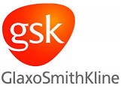
Global Good/Intellectual Ventures will develop for the focus countries new technologies to improve child pneumonia treatment, including a reservoir mask and an oxygen storage system that can significantly increase access to oxygen in settings with unreliable treatment capacities due to unsustainable logistics or interrupted power. In addition, Global Good/Intellectual Ventures will develop better, simpler, more affordable vital sign monitoring tools to enable better management of pediatric patients. Global Good will ensure that stakeholders in the focus countries are aware of these new treatment and patient management technologies and their potential impact on child survival and of the need to invest in the critical health treatment infrastructure that can sustain oxygen systems - from generation, to delivery, to maintenance.

GlaxoSmithKline (GSK) is a multinational pharmaceutical company researching, developing and manufacturing medicines, vaccines and consumer healthcare products including vaccines and antibiotics for the prevention and treatment of childhood pneumonia. GSK is a key vaccine partner of Gavi and is currently in partnership with Save the Children UK to increase amoxicillin coverage in Kenya and the Democratic Republic of Congo, among other things.

GSK will continue to play a key role in the sustainable and accessible supply of childhood immunizations, notably through our PCV Pneumococcal Conjugate Vaccine Synflorix, as well as our respiratory, and cough & and cold medicines. Synflorix is currently used in Universal Mass Vaccination programs in more than 40 countries and, since 2010, more than 300 million doses of Synflorix have been delivered to developing countries through our partnership with Gavi under the Advanced Market Commitment (AMC). As part of this ongoing commitment, GSK will make 720 million doses of Synflorix available by the mid-2020s to help protect children in developing countries. GSK has also pledged to provide Synflorix to Civil Society Organizations (CSOs) delivering immunization programs for refugees in circumstances where governments are not able to respond. GSK and PATH are collaborating to support the implementation of the WHO recommendations for the treatment of childhood pneumonia and neonatal sepsis with amoxicillin dispersible tablets (DT). The study is focused on understanding the current pneumonia and neonatal sepsis treatment landscapes in Bangladesh and Kenya and identifying key bottlenecks that may prevent greater access to, uptake of, and appropriate use of amoxicillin DT in these countries. Depending upon the findings of the study and in collaboration with local stakeholders GSK intends to co-develop a strategy to address critical determinants of access and to address gaps in supply, demand and appropriate use. GSK is also committed to partnering with organizations on joint advocacy efforts to help increase awareness of the impact of pneumonia, as well as gain support from donor and local governments.

Grand Challenges Canada (GCC), funded by the Government of Canada, is dedicated to supporting Bold Ideas with Big Impact. GCC funds innovators in low- and middle-income countries and Canada. With support for more than 800 innovators in over 80 countries, including numerous pneumonia innovations, GCC is one of the largest impact-first investors in Canada.

Grand Challenges Canada (GCC) will evaluate for possible support through its Transition-to-Scale program pneumonia innovations that have the potential to save and improve the lives of pregnant women, newborns and children under five years of age in the focus countries. GCC is committed to stimulating the pipeline for more cost-effective innovations to improve the market for pneumonia diagnosis and treatment in low- and middle-income countries, with a focus on sustainable scale. GCC is also committed to identifying and supporting entrepreneurs and innovators with promising pneumonia technologies from the focus countries.

The ICV Group (Investment Community Visibility) connects hard-to-reach Family Offices and leading Fund Investors to evaluate opportunities that create a social impact beyond a financial return. ICV identifies and empowers change makers who have character, courage and commitment to lead projects that create systemic change, to form unlikely strategic partnerships, to employ innovative financing solutions, and to leverage their convening power to amplify impact.

ICV is committed to mobilizing the funding required to find solutions to the Sustainable Development Goals. In this context, ICV will bring visibility to the burden of pneumonia and catalyze investment in innovations and breakthrough technologies that target the leading killer of children under 5 as part of the overall effort to save women’s and children’s lives.

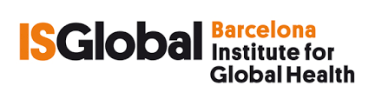
The Barcelona Institute for Global Health (ISGlobal) is an alliance between the "la Caixa" Foundation", academic institutions and government bodies to address the challenges in global health. ISGlobal is a consolidated hub of excellence in research that has grown out of the Hospital Clinic, the Parc de Salut MAR, the University of Barcelona and Pompeu Fabra University. The pivotal mechanism of its work model is the transfer of knowledge generated by scientific research to practice, a task undertaken by the institute’s Education and Policy and Global Development departments. Its ultimate goal is to help close the gaps in health disparities between and within different regions of the world.
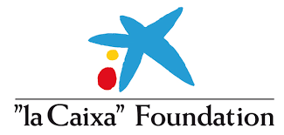
The Barcelona Institute for Global Health (ISGlobal) will provide technical assistance in the specific areas of epidemiology, diagnostics, antimicrobial resistance and post-mortem methodologies, and their links to pneumonia. ISGlobal’s expertise in infectious diseases and respiratory health at a global level, and more particularly on the African continent, will be offered to the Every Breath Counts Coalition and ISGlobal will act as a local and global advocate to enhance pneumonia's visibility and strengthen its recognition as one of the major threats to child survival.
“la Caixa” Foundation is the leading foundation based in Spain. The institution focuses its philanthropic activity on social programs, culture, science and education, for the last 100 years. It is the third foundation worldwide in number of assets. It is dedicated to promoting social development and equal opportunities with special attention to the most vulnerable groups and concentrates its action on promoting transformational social initiatives, investing in research and education and spreading culture and science. Global health innovation and research is a top programmatic priorities.

“la Caixa” Foundation will work to reduce pneumonia-related child mortality by increasing coverage of the PCV vaccine for pneumonia prevention; improving the diagnosis of pneumonia through the use of innovative solutions that automatically measure the respiratory rate (ARIDA) and oxygen saturation (pulse oximetry); increasing the procurement of amoxicillin dispersible tablets and access to oxygen therapy for pneumonia treatment; investing in capacity-building of frontline community health workers as they can have a significant impact in reducing child mortality by timely diagnosis and correct treatment; and raising awareness through advocacy and sensitization campaigns which would, in the medium to long term, strengthen global action and the Sustainable Development Goals agenda to end child deaths by pneumonia by 2030.

Lifebox is a non-profit organization making surgery safer in low resource countries by building professional, academic and commercial networks to increase use of checklists, pulse oximeters, in more than 100 countries. The Lifebox pulse oximeter has been distributed widely to improve anesthesia for surgery and is being adapted and redesigned so that it can be used as a screening tool for childhood pneumonia.

Lifebox will distribute Lifebox pulse oximeters to anesthesia providers in the focus countries and train healthcare and related staff in their use, procurement and maintenance. Further, Lifebox will make the new “newborn and child-friendly” Lifebox probe available in the focus countries in partnership with Great Ormond Street Hospital for Children NHS Foundation Trust (GOSH), the Institute for Global Health at University College London (UCL), and Johns Hopkins University (JHU).
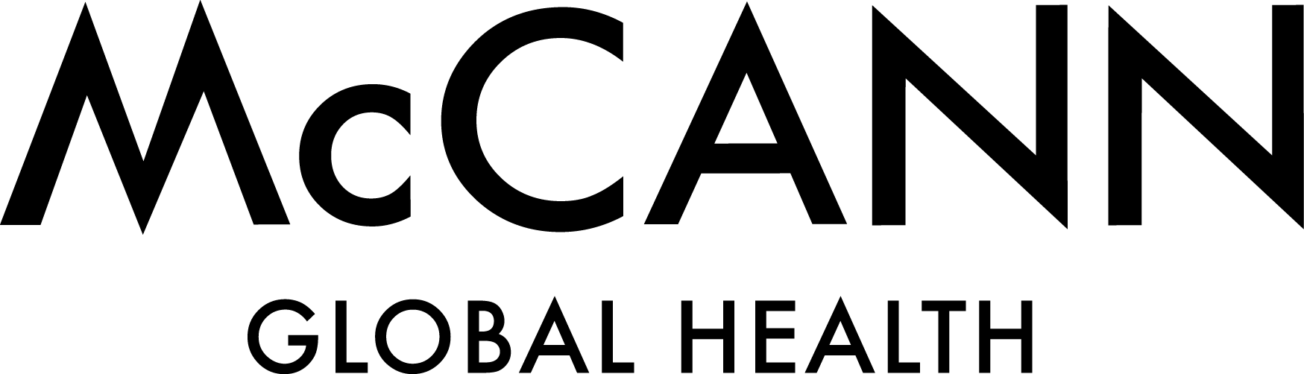
McCann is a multinational advertising agency with a global health team dedicated to improving the quality and impact of public health communications. The global health group has partnered with government, UN and non-profit agencies and other companies on a range of public health campaigns and initiatives, including Zinc+ORS, “Signs of Pneumonia” video series, the Global Breastfeeding Collective, the Global Polio Eradication Initiative, and the Access Accelerated Initiative.

McCann Global Health is committed to providing strategic communications, branding and marketing to raise awareness and deepen the impact of Every Breath Counts globally and in the focus countries. Support could include engaging influencers, executing “deep” communication efforts in the populations of mothers whose children are most at risk in the focus countries and coalescing the voices of all of the various child pneumonia stakeholders into a unified shout through a global brand platform.

Malaria Consortium (MC) is a non-profit organisation specializing in the control of malaria and other communicable diseases – particularly those affecting children under five in Africa and Asia. MC is a leading implementer of community based primary healthcare and is currently involved in Burkina Faso, Chad, Ethiopia, Mozambique, Nigeria, South Sudan and Uganda. This includes work on adherence to antibiotics, rational prescribing, and iCCM guideline development and implementation. Most recently, MC has led a series of trials testing new diagnostic tools to identify children with pneumonia (respiratory rate timers) and hypoxemia (pulse oximeters) to inform global and national policy and program development and investment decisions.

Malaria Consortium will develop a “Child Pneumonia Research Roadmap” to expose knowledge gaps and set research priorities, with special attention to the focus countries. Major research priorities in childhood pneumonia could include, (1) identifying the predictors of development of severe pneumonia and the children who require urgent referral or hospitalization, (2) understanding the main barriers to care seeking for children with pneumonia in different contexts, and which social and behavior change communication strategies can be effective in increasing demand for formal health services, and (3) developing diagnostic tests or diagnostic algorithms than can better detect pneumonia in children.

Masimo is a for-profit company and leader in the manufacture of non-invasive patient monitoring devices including an array of sensors that improve the accuracy, number of false readings, and cost of care. They are committed to increasing access to pulse oximetry in LMICs and are members of the United4Oxygen Alliance with active programs in Ethiopia supported by the Bill & Melinda Gates Foundation.

Masimo will develop a combined pulse oximeter and respiratory rate timer specifically suited to low resource settings and increase its uptake in the focus countries, working with partners to train healthcare staff in its use, procurement and maintenance. With an initial focus on Nigeria and Ethiopia, Masimo will develop models of country engagement that can be expanded to other focus countries in future years.
The Newborn Foundation is a non-profit foundation that applies technology innovation to save newborn lives, with a special focus on expanding access to routine pulse oximetry screening for all newborns in hospitals to detect a range of conditions including newborn pneumonia. The BORN (Birth Oximetry Routine for Newborns) Project is active in China, the Philippines, India, Pakistan, Mongolia, Peru, and Bolivia and the Foundation is an active member of the United4Oxygen Alliance and supports Masimo’s work in Ethiopia and Nigeria.

The Newborn Foundation will expand routine pulse oximetry testing of newborns born in hospitals in the focus countries, with an initial focus on Ethiopia and Nigeria, in partnership with Masimo. The Foundation will also explore the applications of promising new technologies that can reduce newborn deaths, especially from pneumonia, in the focus countries, including lung ultrasound - an early-stage pneumonia diagnostic innovation.
Partners in Health (PIH) is a non-profit organization, which works in 10 countries to support the delivery of high quality healthcare in government health centers and hospitals. A large percentage of patients seen at PIH-supported facilities are children, many of whom have pneumonia. PIH supports sites with staff, mentoring, supplies, and improvements in infrastructure. The PiH model also supports a network of trained, paid community health workers to assure active case finding, adherence to treatment, and patient follow-up for children and adults.

Partners in Health (PiH) will use its close proximity to patient care and connections with Ministries of Health and other policy makers to advocate for increased resources for childhood pneumonia at the global level, and in the countries in which PiH works. PiH can also provide technical assistance to national governments and partners operating in the focus countries on how to strengthen all levels of pediatric pneumonia care - from the community to primary care centers to secondary- and tertiary-level hospitals. PiH can support application of the Mentorship and Enhanced Supervision for Health Care and Quality Improvement (MESH-QI) program, which uses clinical experts to build national capacity and train providers on best practices for the diagnosis and care of childhood pneumonia and other common illnesses.
PATH is a non-profit organization that accelerates innovations in vaccines, drugs, diagnostics, devices, and system and service innovations to help nations in Africa and Asia tackle their greatest health needs. PATH has been very active in the oxygen access agenda leading successful efforts to change WHO policy and engaging with oxygen manufacturers to improve the supply and distribution of appropriate technologies.

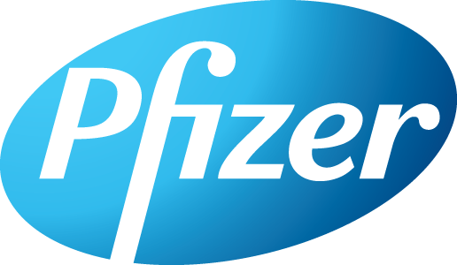
PATH will support efforts to prevent, diagnose and treat child pneumonia in the 10 focus countries as well as globally, with a particular emphasis on vaccines, oxygen therapy, and antibiotic treatment. PATH will continue to apply our expertise in vaccine development and delivery to accelerate the development of new pneumococcal vaccines with an emphasis on ensuring they are effective, affordable, and sustainably accessible for the countries who need them most. To help make oxygen therapy more available and accessible, PATH will advocate at the global, national, and subnational levels for the importance of oxygen in achieving national and global heath goals, especially as they relate to maternal, newborn and child survival. Through dissemination of Oxygen is Essential: A Policy and Advocacy Primer, PATH will arm country advocates with evidence-based resources and messages to inform and engage decision-makers and policy influencers to stimulate their support for increased access to oxygen. In the DRC specifically, PATH will assess the child pneumonia continuum of care landscape, identifying opportunities to strengthen the health system and markets. PATH will also pursue policy change in the DRC that specifically advances access to oxygen therapy with pulse oximetry, and support implementation of this policy down to the subnational level. Globally, PATH will also work with select manufacturers of oxygen technologies to ensure that they design devices to meet the unique needs of low resource settings. PATH will support efforts to include pulse oximetry and oxygen coverage on the Lives Saved Tool (LiST) and integrate coverage into existing global health data surveys and hospital audits. Finally, PATH will also advance the antibiotic innovation agenda by developing new heat stable, ready to use, child friendly formulations of antibiotics like “NutMox” a new formulation of amoxicillin in a peanut butter matrix.

Pfizer applies science and global resources to bring therapies to people that extend and significantly improve their lives. Pfizer’s global portfolio includes medicines and vaccines as well as many of the world's best-known consumer health care products. Pfizer makes quality vaccines designed to help protect as many people as possible from life-threatening illness.

Pfizer will build on the commitment to supply up to 740 million doses of our pneumococcal conjugate vaccine through 2025, via our partnership with Gavi the Vaccine Alliance. Pfizer also provides support for programs and disease awareness, which is intended to help improve vaccination rates. In Niger, Mali, and the DRC, Pfizer supported health care worker training intended to help people recognize the early signs of pneumonia and inform caregivers of the importance of vaccination. Plans are in place to extend this training to Angola. In addition, the Pfizer Foundation supports several programs aimed at increasing access to, and the quality of, immunizations and other health interventions. These programs are considered important to child health and survival in several countries in sub-Saharan Africa, including Ethiopia, Uganda, Malawi, Kenya, and Benin. Note the Pfizer Foundation is a charitable organization established by Pfizer Inc. It is a separate legal entity with distinct legal restrictions.

Philips is a leading health technology company focused on improving people's health and enabling better outcomes across the health continuum from healthy living and prevention, to diagnosis, treatment and home care. Philips leverages advanced technology and deep clinical and consumer insights to deliver integrated solutions. Philips has been working on the development, manufacture and marketing of new pneumonia diagnostic tools including the ChARM monitor, which automatically assesses respiratory rate within minimal input from healthcare workers and an integrated Spot Check Monitor which measures respiratory rate, oxygen saturation (SpO2) and temperature. Philips is ready to contribute to improving pneumonia diagnosis by expanding use of these innovative technologies.
Philips will work in partnership with governments, UN agencies and civil society partners to make the ChARM device available in the focus countries and will explore testing the new integrated Spot Check Monitor in one of the focus countries. In addition to improving diagnosis, Philips is committed to devices that better capture patient data and provider performance cost-effectively and which can be easily shared across large networks informing further performance improvement.
Results for Development (R4D) is a non-profit global development partner which collaborates with change agents around the world — government officials, civil society leaders and social innovators — to create strong systems that support healthy, educated people. R4D combines global expertise in health, education and nutrition with analytic rigor, practical support for decision-making and implementation and access to peer problem-solving networks.
Results for Development (R4D) will support activities to increase the availability and use of child pneumonia treatments in public health facilities in Ethiopia. In partnership with the Government of Ethiopia and other key stakeholders, R4D will increase awareness of amoxicillin dispersible tablets as the first-line treatment for pneumonia amongst health practitioners and policymakers at the regional and district levels; ensure that robust quantifications and financial gap analyses for amoxicillin dispersible tablets are conducted; engage with high-quality manufacturers of amoxDT to encourage registration in country; and continue to administer catalytic procurement funding while supporting the Federal Ministry of Health to mobilize domestic funding sources for amoxDT. Additionally, R4D will share learnings from its formative research in Tanzania to ascertain rates of over- and under-diagnosis of pneumonia and to identify and pilot interventions that could drive increased rational use of amoxDT. R4D’s findings could be leveraged in Coalition focus countries to improve the quality of care around childhood pneumonia.

Save the Children (StC) is a global network of non-profit organizations with a presence in more than 120 countries, each promoting children's rights, and providing education, health care, emergency aid in natural disasters, war, and other conflicts. Save the Children was a founding member of World Pneumonia Day and will lead a major focus on pneumonia as part of its plans to celebrate its Centennial Year.

Save the Children will partner in four of the focus countries (and others) to change the trajectory of child pneumonia deaths through programming, policy, advocacy, innovations, research and campaigns. StC will work to build global political attention for pneumonia mortality within the movements to end all preventable child deaths, to improve women’s children’s and adolescents’ health and nutrition, and Universal Health Coverage. StC will champion innovative and equitable approaches to pneumonia prevention, diagnosis and treatment by expanding the reach and impact of the Pneumonia Innovations Network, a 350 strong global network of innovators advancing better ways to prevent, diagnose and treat child pneumonia, which will be hosted by Save the Children, and StC will champion reductions in PCV vaccine pricing to reduce the costs to non-Gavi eligible countries. Save the Children’s global advocacy to end preventable child pneumonia deaths will include the education and engagement of a new generation of “influencers”, the publication of reports, and the inclusion of child pneumonia at high-level gatherings of development leaders, including at World Bank annual meetings and the UHC Forum in Japan in December, 2017.

Speak Up Africa (SUA) is a non-profit advocacy and communications organization that facilitates African leadership and ownership and empowers communities to advance the health and development of children, with a special focus on the neglected leading killers of children - pneumonia and diarrhea. SUA has already initiated several pneumonia-specific campaigns in Nigeria and Ethiopia, and is currently building a network of influencers in Niger and Chad.

Speak Up Africa will work through campaigns, the recruitment of high profile influencers and through quiet advocacy in any and all of the focus countries to raise the profile of pneumonia and to catalyze resource mobilization and policy change in order to reduce child pneumonia deaths. Resource mobilization will include domestic support in the preparation of investment cases for Global Financing Facility funding and policy change will focus on increasing universal access to prevention tools like immunization, breastfeeding, nutrition and diagnostic and treatment tools. A key focus will be on increasing grassroots demand for prevention, diagnostic and treatment tools through mother and caregiver focused campaigns. Speak Up Africa will identify and engage African leaders to champion action on child pneumonia in the focus countries by working with former President Kikwete, HE Moussa Faki, the leadership of the African Union, the leadership at WHO AFRO, the Organisation of African Ladies against HIV/AIDS (OAFLA), a variety of sports institutions including the Confederation of African Football and other decision-makers and influencers. Building on the child pneumonia campaigns already executed in Nigeria with the First Lady, Speak Up Africa will develop creative content for both advocacy and social behavior change targets, and assist with dissemination in other focus countries. Speak Up Africa will focus at the global level on promoting awareness of the current mismatch between the global burden of pneumonia and the small amount of global funding allocated to pneumonia.
UNICEF is mandated by the United Nations General Assembly to advocate for the protection of children's rights, to help meet their basic needs and to expand their opportunities to reach their full potential, serving the most disadvantaged children and the countries in greatest need first. UNICEF continues to produce data and reports on pneumonia (One is Too Many, Clean the Air for Children), to procure amoxicillin dispersible tablets, and to stimulate the pipeline for better pneumonia diagnostic tools through the ARIDA Project and by updating guidance for the procurement of pulse oximetry and oxygen devices.

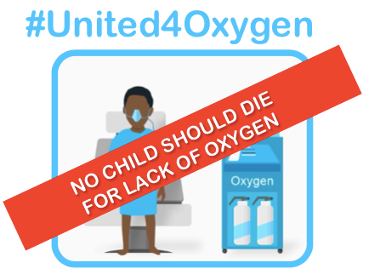
UNICEF will work in partnership with WHO and other stakeholders to accelerate child pneumonia mortality declines in the focus countries by: (1) advancing WHO pre-qualification for the medicines used to treat pneumonia, including amoxicillin dispersible tablets and antibiotic injectables for sick newborns, (2) Encouraging countries to participate to the WHO collaborative procedure for accelerated registration, and incorporating mutual recognition of registration which will help improve access where product registration could have been a barrier, (3) supporting the development of local markets and production for quality amoxicillin dispersible tablets and other medicines used to treat pneumonia, (4) improving access to new tools for early and more effective diagnosis and management of pneumonia and hypoxemia with support from “la Caixa” Foundation, and (5) improving procurement mechanisms for oxygen technologies, with support from the Bill & Melinda Gates Foundation. Further, UNICEF will provide technical support to focus countries for pneumonia prevention and treatment – including efforts to improve household air quality, breastfeeding rates and child nutrition, and PCV vaccine coverage, as well as increasing understanding of the links between these investments and child pneumonia mortality reductions. UNICEF will work closely with the US Fund for UNICEF to raise awareness and mobilize resources from US donors for the prevention, diagnosis and treatment of childhood pneumonia.

United4Oxygen is a first-of-its-kind public-private partnership with the goal of increasing access to pulse oximetry diagnostics and oxygen therapy in health facilities serving women and children. United4Oxygen was launched as a Clinton Global Initiative Commitment to Action in September 2016, and currently works to support the Government of Ethiopia's National Medical Oxygen and Pulse Oximetry Scale Up Road Map. The Clinton Global Initiative (CGI) is a non-profit initiative of the Clinton Foundation that convenes cross-sector actors to address the world's most pressing challenges.

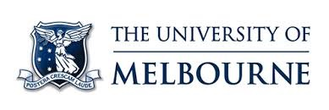
The United4Oxygen Alliance, which includes companies, non-profits, and UN and government agencies, will expand its work to Nigeria, specifically to support the Government of Nigeria’s national plan to improve access to pulse oximetry screening and oxygen therapy. United4Oxygen will mobilize existing partners and engage new partners with a presence in Nigeria to, (a) increase the availability of pulse oximetry screening and oxygen therapy in health facilities, (b) train local staff in the use of new technologies, (c) establish sustainable financing solutions for the procurement, installation, and maintenance of new equipment, and (d) support the government to measure the impact of the initiative on national child survival goals. This work will be launched as a second CGI Commitment to Action and will build on best practices from the Alliance's work in Ethiopia. United4Oxygen partners include Adara Development, Assist International, GE Foundation, Bill & Melinda Gates Foundation, Centre for International Child Health, Diamedica, Center for Public Health and Development, Gradian Health Systems, Grand Challenges Canada, Malaria Consortium, Masimo, PATH, Philips, Pneumonia Innovations Network, Save the Children, UNICEF, University of Alberta, USAID, and the World Federation of Societies of Anaesthesiologists (WFSA).

The University of Melbourne’s Centre for International Child Health is a WHO collaborating centre for child health and a leading global child health research institution. The Centre has led the development of child health guidelines, including the WHO Oxygen Therapy for Children (2016), and has pioneered oxygen work in Papua New Guinea, Laos, and Nigeria.

The University of Melbourne’s Centre for International Child Health will support hospitals and governments in Nigeria and Ethiopia to implement effective oxygen systems through oxygen and pulse oximetry training, equipment installations, technical support, and testing of novel oxygen systems. The Centre will share results and materials from these activities for wider learning and dissemination.

The U.S. Agency for International Development (USAID) is the lead U.S. Government agency that works to end extreme global poverty and enable resilient, democratic societies to realize their potential. One of USAID’s key global health priorities is preventing child deaths and playing a strong role in advocating for child survival. USAID is involved in multiple pneumonia-specific initiatives, including the “Signs of Pneumonia” video series, increasing access to amoxicillin dispersible tablets, developing educational kits for caregivers and frontline health workers to encourage care-seeking and accurate diagnosis/treatment, and United4Oxygen.

To address slow progress in reducing pneumonia related deaths, USAID and UNICEF are partnering to support country-led strategies to fight pneumonia within the context of their basic package of services. This will involve understanding the supply- and demand- side barriers to pneumonia prevention, diagnosis, and treatment, and will draw on best practices and innovations to overcome existing obstacles. USAID continues to focus on the prevention, diagnosis, and treatment of pneumonia as part of our overall effort to save women's and children's lives.

What are Every Breath Counts Coalition partners saying?
“In countries, care seeking is a huge challenge. Our work in Ethiopia has revealed that mothers don't recognize pneumonia until it is severe and in many settings the majority of pneumonia deaths are occurring in hospitals due to lack of available appropriate care (e.g. limited access to oxygen).” Kate Schroder, Vice President Essential Medicines, Clinton Health Access Initiative
“It is important that there is a national country plan or strategy of action endorsed by political leaders and ministries of health that external partners can align around. For example in the pneumonia area, one of the first tasks would be national engagement and analysis that identifies the major prevention, diagnosis and treatment coverage gaps in child pneumonia that governments could get behind. This is the way the United4Oxygen process has worked in Ethiopia.” Bekah Curtis-Heald, United4Oxgen Alliance, Clinton Global Initiative

“Current technologies for the diagnosis and treatment of childhood pneumonia are inadequate and. Up to 40% of cases are misdiagnosed and there is so much overprescription of antibiotics. A key technology challenge is creating the tools that allow health workers to differentiate the children with pneumonia who are in immediate danger; who will die within 24 hours, and act quickly and appropriately.” Akos Somoskovi, Specialist in Respiratory Medicine and Clinical Oncology, Global Good/Intellectual Ventures

“A more ambitious pneumonia mortality “elimination” target is needed and achievable with coordinated action in specific settings and domestic support. There is also a limited understanding in the health sector - including at the global level - of the links between air pollution and child survival, which is tragic given how much of the health budget is actually spent trying to undo the negative health impacts of air pollution.” Sumi Mehta, Senior Director for Research and Evaluation, Global Alliance for Clean Cookstoves

“GSK remains committed to doing more to reduce child pneumonia deaths including through our child health partnership with Save the Children, our vaccine partnership with Gavi and by supporting Every Breath Counts to close gaps to reduce deaths in the largest populations of children at greatest risk of pneumonia.” Lisa Bonadonna, Global Head of GSK-Save the Children Partnership & Access Medicines Portfolio, GSK
“McCann has learned through our communications work in breastfeeding, diarrhea, pneumonia, non-communicable diseases and polio that directly educating mothers whose children face the greatest health risks is a key missing piece. Efforts need to make mothers more aware of how to prevent pneumonia (vaccines, nutrition, clean cooking, sanitation etc) and how to recognize the symptoms and act quickly when children fall ill. communication effort. Focus countries will need their own pneumonia communications strategy.” Andrew Schirmer, President, McCann Global Health
“We need to make sure that donor governments with big commitments to global health and child survival, companies, multi-laterals (e.g. World Bank, Gavi) and major foundations understand that child pneumonia is the leading infectious disease threat to children globally, and in most low and middle income countries.” Bonnie Keith, Senior Policy and Program Officer, PATH

“Save the Children is committed to joining forces with other organisations to elevate child pneumonia on the global heath and development agendas and to elevating the advocacy push to new heights and introducing new programs that accelerate child mortality declines to the levels needed to achieve the SDGs.” Kevin Watkins, CEO, Save the Children (UK)

“Save the Children fully supports setting a more ambitious goal - such as ending preventable child pneumonia deaths by 2030 - and a broader public-private partnership that shows how this can be achieved in the specific countries where children are most vulnerable.” Carolyn Miles, CEO, Save the Children (US)

“Nothing will be achieved without national leadership in the endemic countries so a great deal more effort needs to be put into advocating directly to governments at all levels (federal, state and local) and mobilizing for behavior change in affected populations via social media and more traditional approaches where relevant (e.g. radio).” Kate Campana, CEO, Speak Up Africa

“We welcome this push for a deeper multi-country effort on child pneumonia deaths and support the more ambitious “elimination” target by 2030. Because ending preventable child pneumonia deaths requires simultaneous action on vaccines, nutrition, environmental pollution, and health services, pneumonia could be used as a “litmus test” for how well a country’s health system is actually functioning for children. It could be a test case for an“integrated” health system.” Stefan Peterson, Chief of Health, UNICEF
“Reducing childhood pneumonia deaths is not a “one intervention” issue. The challenge is multifaceted and must begin with a mother's nutritional status, embrace vaccine introduction, and access to medicines as well as other interventions and multiple points along the value chain. Achieving success in fighting childhood pneumonia requires partners from all sectors to work on all of these issues in a coordinated way. To show results, it is important that we use data to highlight a subset of countries where gains can be made and support countries to develop plans of action.” David Milestone, Acting Director, Center for Accelerating Innovation and Impact, USAID.

UNICEF, Committing to Child Survival: A Promise Renewed Progress Report, 2015.
SDG 3.2 requires all countries to reduce newborn and child mortality to below 12 and 25 deaths per 1,000 live births respectively by 2030.
Institute for Health Metrics and Evaluation, Pushing the Pace: Progress and Challenges in Fighting Childhood Pneumonia, 2014.

