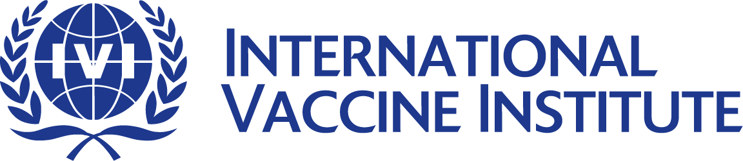
News Release

FOR IMMEDIATE RELEASE
11 a.m., Friday, November 12, 2010 (KOREA TIME)

IVI pairs up with Amway to raise awareness of pneumonia
Seoul-based international organization participates in “World Pneumonia Day” campaign on Nov. 12
Every year 1.5 million children under age 5 years die from pneumonia; prevention education is essential

SEOUL, Korea – The International Vaccine Institute (IVI) has participated in a publicity campaign on “World Pneumonia Day” to raise awareness about the dangers of pneumonia and its prevention methods. Sponsored by Amway Korea, the local operation of the multinational firm, the campaign started with a kickoff event on November 12 entitled, “Making a healthier world,” in Myeongdong in central Seoul, Korea.

World Pneumonia Day was first established in 2009 by the Global Coalition against Child Pneumonia to mobilize world-wide efforts to prevent and control pneumonia, an infectious syndrome that kills an estimated 1.5 million children under age five years yearly. To leverage such global efforts, the campaign in Korea will focus on children, people with underlying health problems and senior citizens by educating the public on prevention and early treatment methods. Significantly, this is the first campaign of its kind for pneumonia to be launched in Korea.

The kickoff event in Myeongdong under the theme; “Fight pneumonia, save a child” showcased several attractions that educated citizens about the disease. With performances by mascot characters and help from public figures- winners of 2010 Miss Korea, Jung So-ra, Jang Yoon-jin, and Ahn Da-hye, the event increased public awareness about the seriousness of pneumonia and the importance of prevention.

IVI’s project will also entail a nationwide health education program for parents to be held at social welfare centers under the sponsorship of Amway Korea. Parents will be educated in pneumonia recognition and prevention, including vaccination. Currently, pneumococcal vaccination for children in Korea is recommended but not mandatory. To accelerate the campaign, public service announcements will be produced and aired, and a website (www.wpdk.ivi.int) will be launched to share more information on pneumonia and promote World Pneumonia Day.

In commemoration of Amway’s 50th anniversary, Amway Korea has been staging a corporate social responsibility campaign jointly with the IVI under the theme “I Love One by One” since October last year to help improve health and save lives of children. Last July, the IVI and Amway Korea conducted a G20 Global Kids’ Camp, an educational camp for children from low income and multicultural families designed to cultivate their sense of dignity and enhance recognition as global citizens.

About the IVI
The International Vaccine Institute (IVI) is the world’s only international organization devoted exclusively to developing and introducing new and improved vaccines for the world’s poorest people, especially children in developing countries. Established as an initiative of the United Nations Development Program in 1997, the IVI operates under a treaty signed by 40 countries and the World Health Organization. The IVI conducts research in more than 30 countries in Asia, Africa and Latin America on vaccines against diarrheal infections, bacterial meningitis and pneumonia, Japanese encephalitis, dengue fever and more. For further information, please visit: www.ivi.int

World Pneumonia Day Mission
The Global Coalition against Child Pneumonia was established in April 2009. It seeks to bring focus on pneumonia as a public health issue and to prevent the millions of avoidable deaths from pneumonia that occur each year. The Coalition is grounded in a network of international government, nongovernmental and community‐based organizations, research and academic institutions, foundations, and individuals that have united to bring much‐needed attention to pneumonia among donors, policy makers, health care professionals, and the general public. WPD highlights the fact that a large number of babies and children are at risk of death due to pneumonia. WPD activities seek to educate, inform and inspire individuals and organizations to take action in learning more about pneumonia, recognition of pneumonia and to develop understanding of approaches for pneumonia prevention.

ATTACHMENT:
The Pneumonia Education and World Pneumonia Day Project Partnership
Pneumonia in Children: A Fact Sheet for Parents in Korea

IVI Contact

Tae Kyung Byun
Public Awareness/Advocacy Officer

SNU Research Park, San 4-8 Nakseoungdae-dong, Gwanak-gu, Seoul, Korea 151-191
Tel: +82-2-881-1159 (Dir) +82-2-872-2801 (Ext. 159)
Mobile: 011-9773-6071
Fax: +82-2-881-1228
Email: tkbyun@ivi.int

